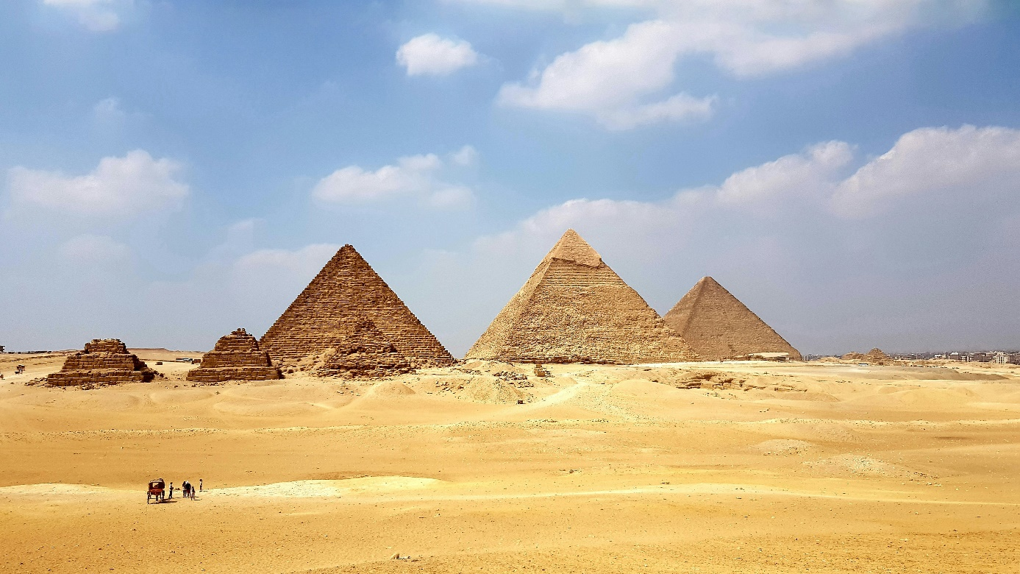

Foto von [Osama Elsayed](https://unsplash.com/de/@osamaabosaadia?utm_content=creditCopyText&utm_medium=referral&utm_source=unsplash) auf [Unsplash](https://unsplash.com/de/fotos/braune-pyramide-unter-blauem-himmel-tagsuber-vqRMXgVtGXM?utm_content=creditCopyText&utm_medium=referral&utm_source=unsplash)

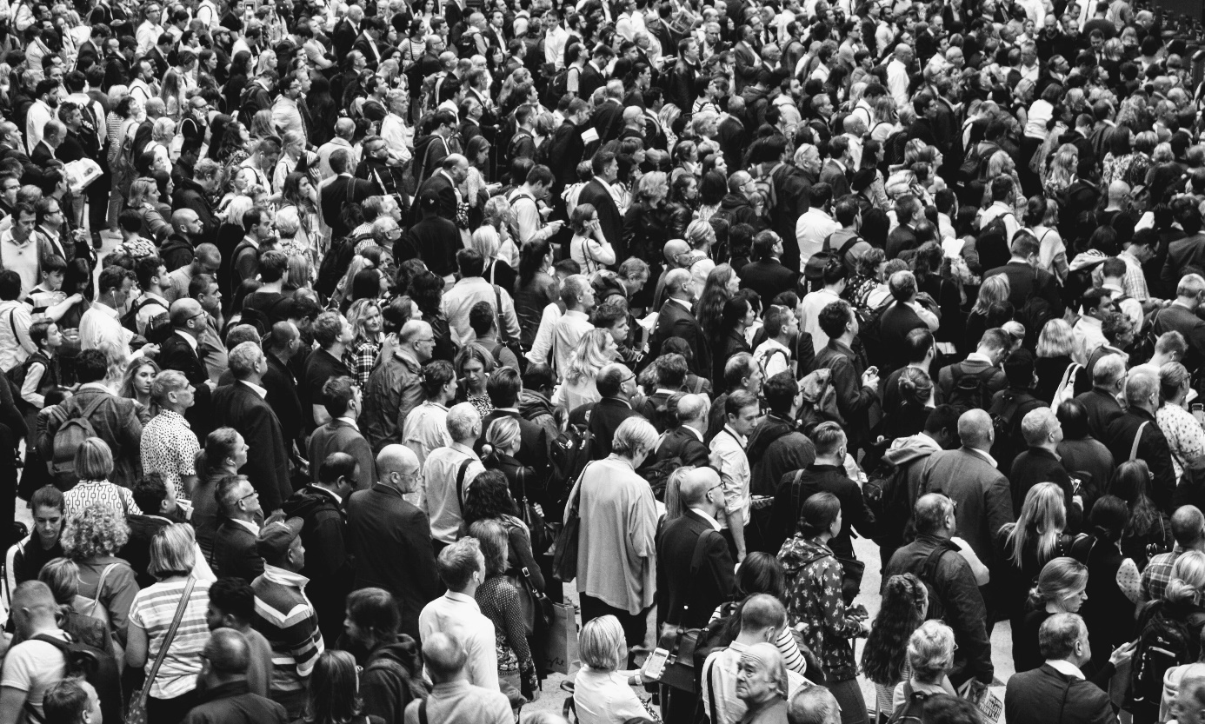

Foto von [Rob Curran](https://unsplash.com/de/@curranrob?utm_content=creditCopyText&utm_medium=referral&utm_source=unsplash) auf [Unsplash](https://unsplash.com/de/fotos/graduales-foto-von-menschen-die-auf-dem-boden-stehen-sUXXO3xPBYo?utm_content=creditCopyText&utm_medium=referral&utm_source=unsplash)

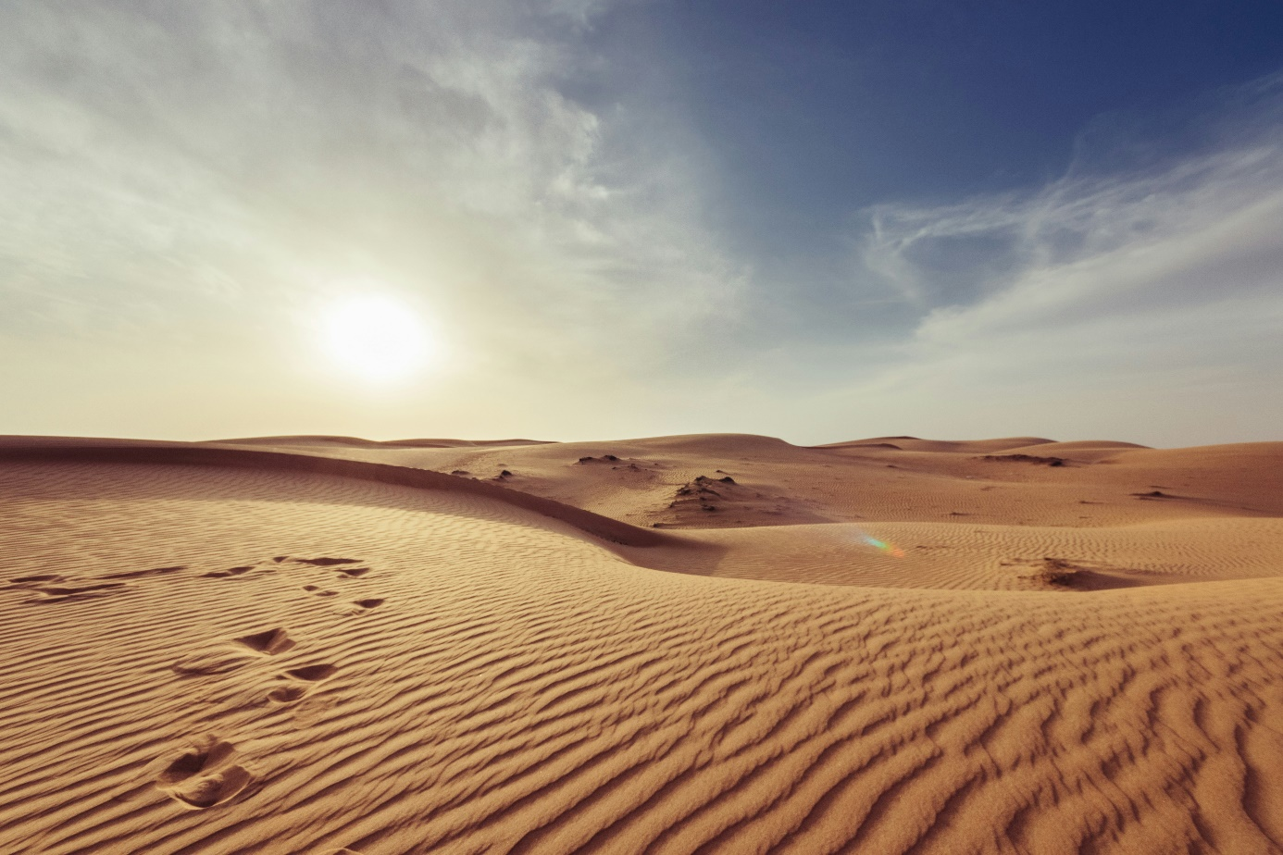

Foto von [Giorgio Parravicini](https://unsplash.com/de/@parradesign?utm_content=creditCopyText&utm_medium=referral&utm_source=unsplash) auf [Unsplash](https://unsplash.com/de/fotos/grauer-sand-unter-weissem-und-blauem-himmel-12IHVEFRacQ?utm_content=creditCopyText&utm_medium=referral&utm_source=unsplash)

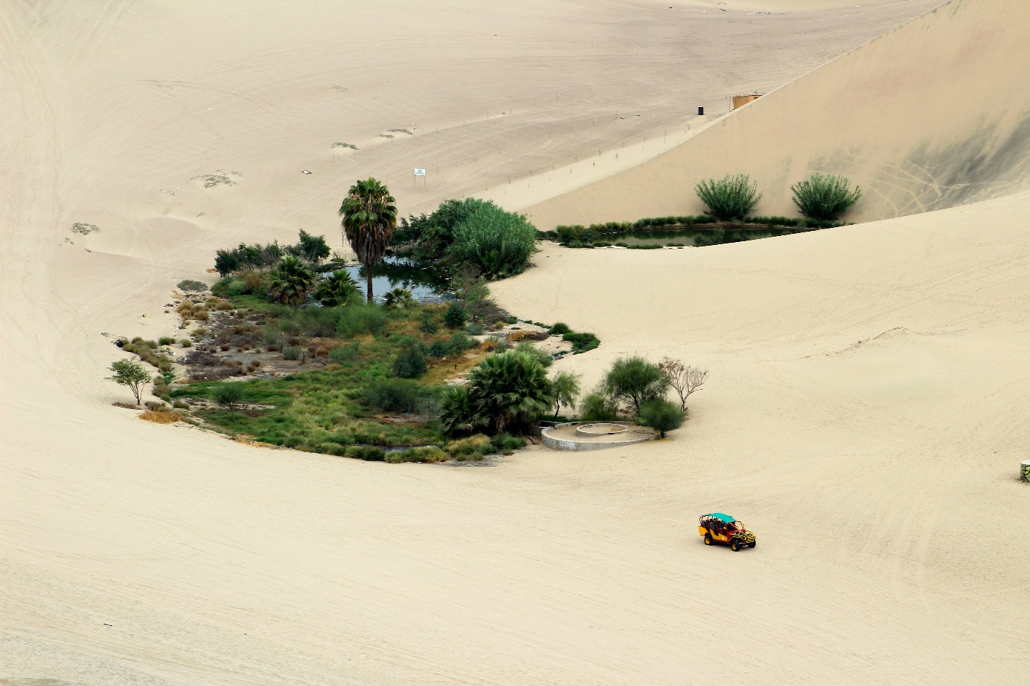

Foto von [Sandra Gabriel](https://unsplash.com/de/@sandragabriel?utm_content=creditCopyText&utm_medium=referral&utm_source=unsplash) auf [Unsplash](https://unsplash.com/de/fotos/gelbes-und-blaues-auto-auf-braunem-sand-s-7E4qC03oU?utm_content=creditCopyText&utm_medium=referral&utm_source=unsplash)



Foto von [Wesley Tingey](https://unsplash.com/de/@wesleyphotography?utm_content=creditCopyText&utm_medium=referral&utm_source=unsplash) auf [Unsplash](https://unsplash.com/de/fotos/ein-holzerner-richterhammer-auf-einem-tisch-RnfF8SXkzRw?utm_content=creditCopyText&utm_medium=referral&utm_source=unsplash)



Foto von [Paweł Furman](https://unsplash.com/de/@pawelo81?utm_content=creditCopyText&utm_medium=referral&utm_source=unsplash) auf [Unsplash](https://unsplash.com/de/fotos/person-mit-rot-weissem-kittel-jo21H-4lYFU?utm_content=creditCopyText&utm_medium=referral&utm_source=unsplash)

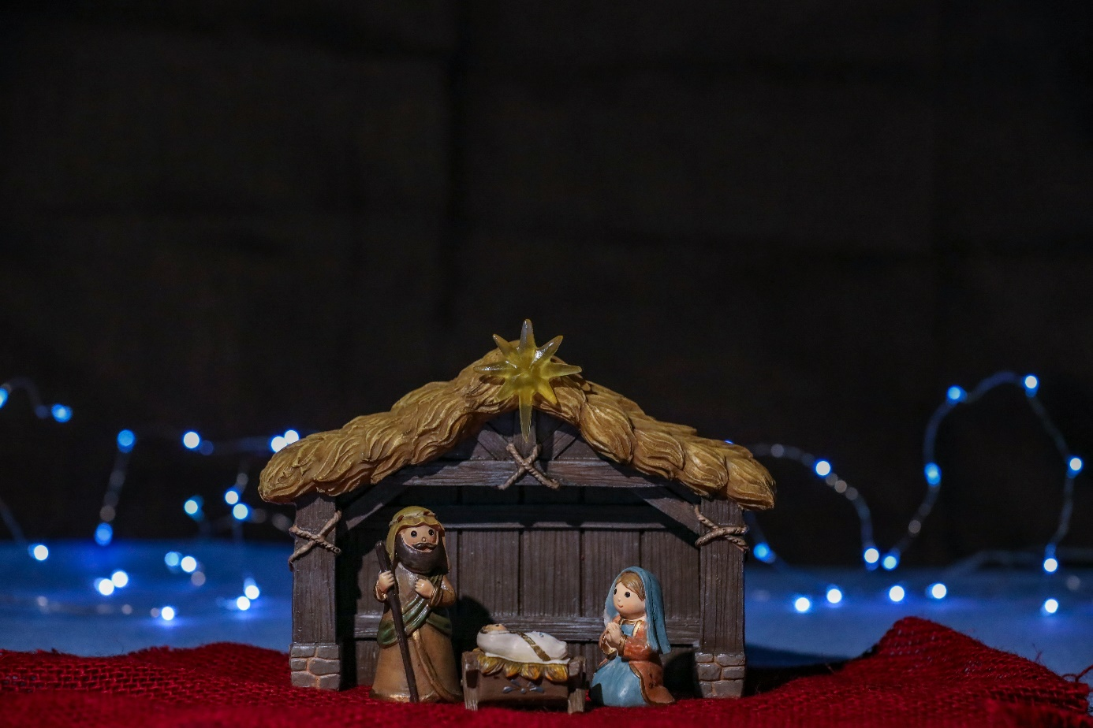

Foto von [Mick Haupt](https://unsplash.com/de/@rocinante_11?utm_content=creditCopyText&utm_medium=referral&utm_source=unsplash) auf [Unsplash](https://unsplash.com/de/fotos/krippenfigur-in-der-nacht-4FabXB48IF8?utm_content=creditCopyText&utm_medium=referral&utm_source=unsplash)

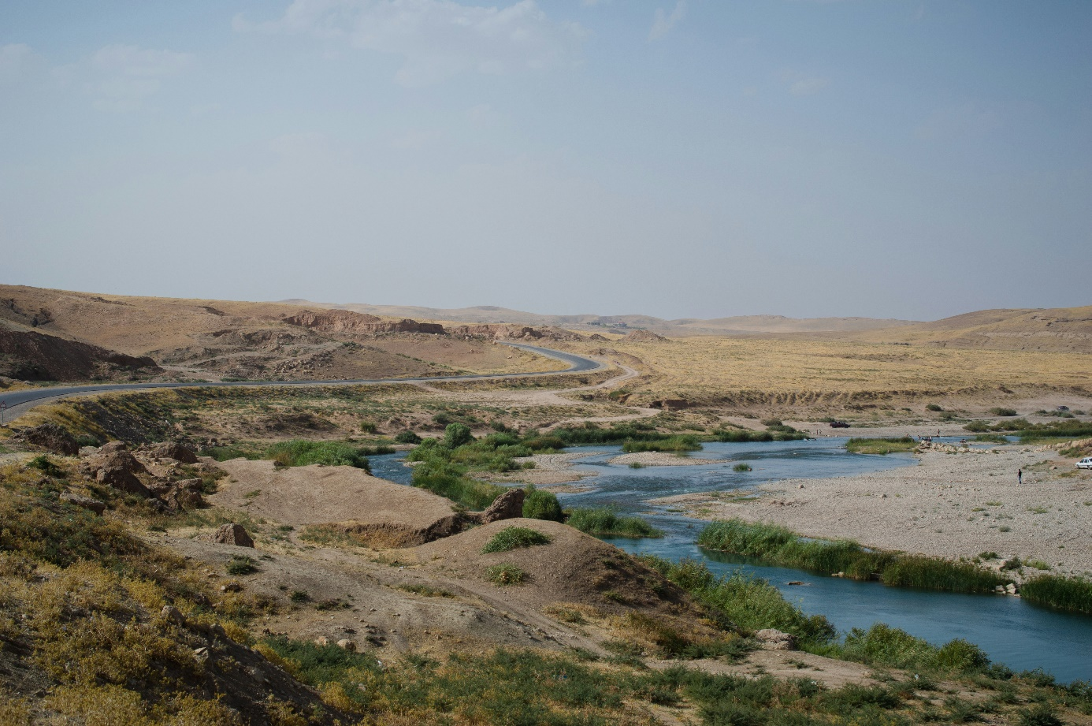

Foto von [Levi Meir Clancy](https://unsplash.com/de/@levimeirclancy?utm_content=creditCopyText&utm_medium=referral&utm_source=unsplash) auf [Unsplash](https://unsplash.com/de/fotos/ein-gewasser-J3esKvkW-TY?utm_content=creditCopyText&utm_medium=referral&utm_source=unsplash)